**PHG-206A Online PH Sensor**

**User Manual**

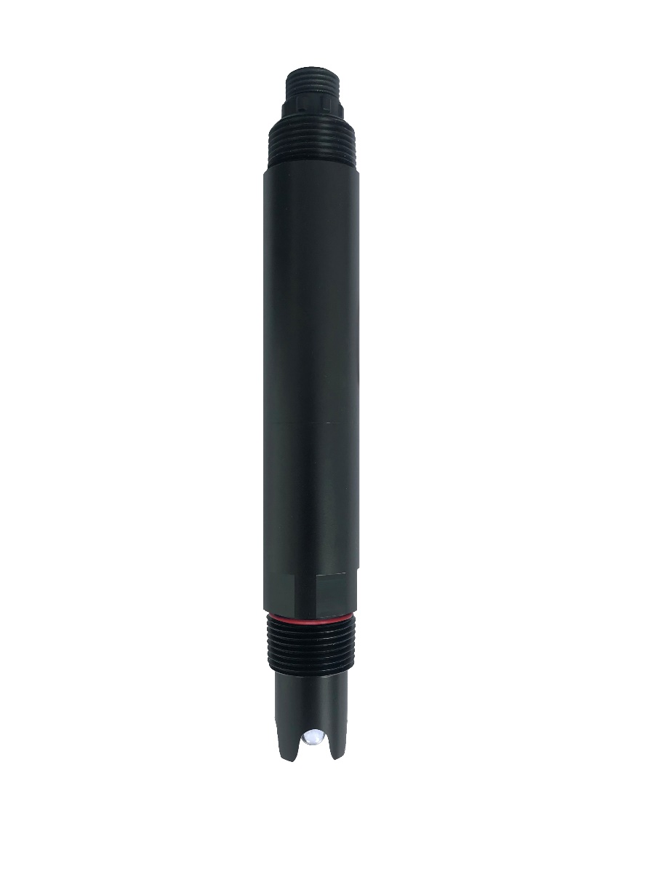

# User Notes

* Please read the instruction carefully before using and save it for reference.
* Please follow the instructions and precautions.
* When receiving the instrument, please open the packaging carefully, inspect equipment’s damage level in case of transportation, if you found spoiled equipment, please immediately notify the manufacturer and distributor, and retain the packaging, in order to send back to processing.
* When the instrument is in trouble, please don’t repair it by yourself, please directly contact the maintenance department of the manufacturer.

Content

User Notes 2

Ⅰ、 Application Environment 4

Ⅱ、 Technical performance and specifications 4

1. Technical parameters 4

2. Dimensional drawing 5

Ⅲ、 Installation and electrical connection 5

1. Installation 5

2. Electrical connection 6

Ⅳ、 Maintenance and maintenance 6

1. Use and maintenance 6

2. Calibration 7

Ⅴ、 Quality and service 7

1. Quality assurance 7

2. Accessories and spare parts 8

3. After-sales service commitment 7

Appendix data communication 8

## Ⅰ、Application Environment

Used for environmental water quality monitoring, acid/alkali/salt solution, chemical reaction process and industrial production process, it can meet the requirements of online pH measurement for most industrial applications.

* Signal output: RS-485 (Modbus/RTU protocol).
* Convenient connection to third-party devices such as PLCs, DCS, industrial control computers, general-purpose controllers, paperless recording instruments or touch screens.
* Dual high-impedance differential amplifier with strong anti-interference and fast response.
* The patented pH probe, the internal reference solution oozes extremely slowly from the microporous salt bridge at a pressure of at least 100 kpa (1 Bar), and its forward bleed continues for more than 20 months. Such a reference system is very stable and the electrode life is extended by a factor of two compared to conventional industrial electrodes.
* Easy to install: 3/4 NPT pipe thread for easy submersible installation or installation in pipes and tanks.
* IP68 protection grade.

## Ⅱ、Technical performance and specifications

### Technical parameters

|  |  |
| --- | --- |
| **Model** | PHG-206A |
| **Measuring range** | 0～14pH |
| **Resolution** | 0.01pH |
| **Accuracy** | ±0.1pH，±0.3℃ |
| **Working temperature** | 0～65℃ |
| **Working pressure** | ＜0.2MPa |
| **Temperature compensation** | Auto temperature compensation (NTC) |
| **Power supply** | 12～24VDC |
| **Signal output** | RS-485(Modbus/RTU) |
| **Wetted material** | POM |
| **Mounting method** | Immersion mounting, 3/4 NPT thread |
| **Cable length** | 5 meters, other lengths can be customized |
| **Calibration** | Two-point calibration |
| **Power consumption** | 0.2W@12V |
| **Protection grade** | IP68 |

### Dimensional drawing

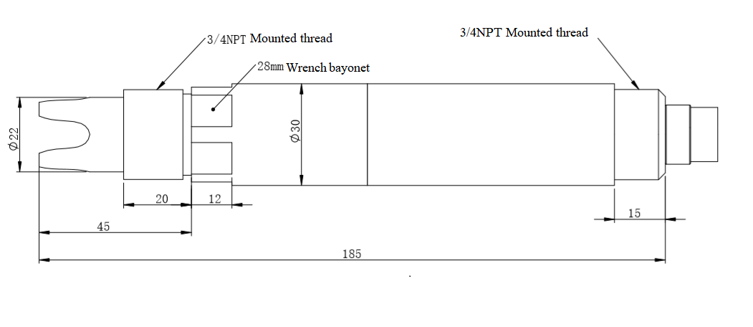

Note:The sensor connector is M16-5 core waterproof joint male head.

## Ⅲ、Installation and electrical connection

### Installation

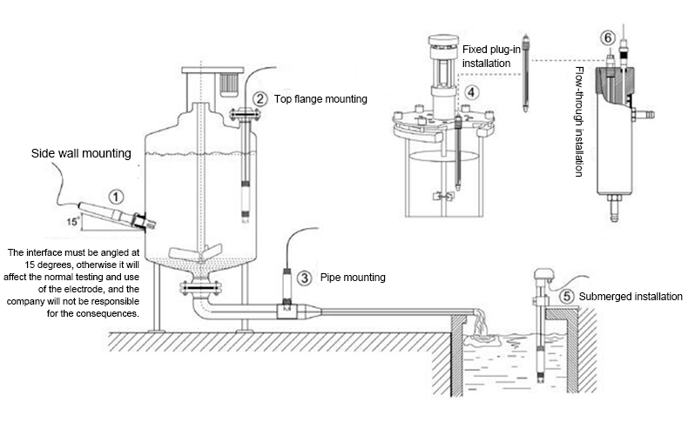

Note: The sensor should not be installed upside down or horizontally when installed, at least at an angle of 15 degrees or more.

### Electrical connection

a) Red line - power cord (12 ~ 24V)

b) Black line - ground (GND)

c) Blue line - 485A

d) white line - 485B

After wiring is completed, it should be carefully checked to avoid incorrect connections before powering up.

Cable specification: Considering that the cable is immersed in water (including sea water) for a long time or exposed to the air, all the wiring points are required to do waterproof treatment, the user cable should has certain corrosion resistance.

## Ⅳ、Maintenance

### Use and maintenance

When using the pH sensor, it should be cleaned in distilled water (or deionized water), and the filter paper should be used to absorb moisture to prevent impurities from being introduced into the liquid to be tested. 1/3 of the sensor should be inserted into the solution to be tested.

The sensor should be washed when not in use, inserted into a protective sleeve with a 3.5 mol/L potassium chloride solution, or the sensor inserted into a container with a 3.5 mol/L potassium chloride solution.

Check if the terminal is dry. If it is stained, wipe it with absolute alcohol and dry it. Avoid long-term immersion in distilled water or protein solution and prevent contact with silicone grease. With a longer sensor, its glass film may become translucent or with deposits, which can be washed with dilute hydrochloric acid and rinsed with water. The sensor is used for a long time. When a measurement error occurs, it must be calibrated with the meter for calibration.

When the calibration and measurement cannot be performed while the sensor is being maintained and maintained in the above manner, the sensor has failed. Please replace the sensor.

**Standard buffer pH reference table**

|  |  |  |  |  |  |  |
| --- | --- | --- | --- | --- | --- | --- |
| Temp(℃) | 4.00 | 4.01 | 6.86 | 7.00 | 9.18 | 10.01 |
| 0 | 4.00 | 4.00 | 6.98 | 7.12 | 9.46 | 10.32 |
| 5 | 4.00 | 4.00 | 6.95 | 7.09 | 9.39 | 10.25 |
| 10 | 4.00 | 4.00 | 6.92 | 7.06 | 9.33 | 10.18 |
| 15 | 4.00 | 4.00 | 6.90 | 7.04 | 9.28 | 10.12 |
| 20 | 4.00 | 4.00 | 6.88 | 7.02 | 9.23 | 10.06 |
| 25 | 4.00 | 4.01 | 6.86 | 7.00 | 9.18 | 10.01 |
| 30 | 4.01 | 4.02 | 6.85 | 6.99 | 9.14 | 9.97 |
| 35 | 4.02 | 4.02 | 6.84 | 6.98 | 9.17 | 9.93 |
| 40 | 4.03 | 4.04 | 6.84 | 6.97 | 9.07 | 9.89 |
| 45 | 4.04 | 4.05 | 6.83 | 6.97 | 9.04 | 9.86 |
| 50 | 4.06 | 4.06 | 6.83 | 6.97 | 9.02 | 9.83 |

The actual reading and standard of the instrument sometimes have an error of ±1 word.

### Calibration

Note: The sensor has been calibrated before leaving the factory. If the measurement error is not exceeded, it should not be arbitrarily calibrated.

a) Zero calibration

Use 250 mL of distilled water in a measuring cylinder, pour into a beaker, add a packet of calibration powder with pH=6.86, stir evenly with a glass rod until the powder is completely dissolved, configure the solution with pH=6.86, put the sensor into the solution, wait for 3 ～5 minutes, after the value is stable, see if the displayed value is 6.86. If not, you need to perform zero calibration. Refer to the appendix for the calibration instructions.

b) Slope calibration

For acidic solution: Take 250 mL of distilled water in a measuring cylinder, pour into a beaker, add a packet of calibration powder with pH=4.00, stir evenly with a glass rod until the powder is completely dissolved, and configure the solution to pH=4.00; In the solution, wait for 3 to 5 minutes. After the value is stable, see if the value is 4.00. If not, the slope calibration is required. Refer to the appendix for the calibration instructions.

For alkaline solution: Take 250 mL of distilled water in a measuring cylinder, pour into a beaker, add a packet of calibration powder with pH=9.18, stir evenly with a glass rod until the powder is completely dissolved, and configure the solution to pH=9.18; In the solution, wait for 3 to 5 minutes. After the value is stable, check if the display is 9.18. If not, the slope calibration is required. Refer to the appendix for the calibration instructions.

## Ⅴ、Quality and service

1. **Quality assurance**

* The quality inspection department has standardized inspection procedures, advanced and perfect testing equipment and means, and strictly in accordance with the regulations, to do 72-hour aging test and stability test on the product, and not to allow one unqualified product to leave the factory.
* The receiving party directly returns the product batch with a failure rate of 2%, and all the costs incurred are borne by the supplier. The reference standard refers to the product description provided by the supplier.
* Guarantee the quantity of goods and the speed of shipment.

1. **Accessories and spare parts**

This product includes:

* 1 sensor
* Calibration powder 3 packs
* 1 copy of the manual
* 1 certificate

1. **After-sales service commitment**

The company provides local after-sales service within one year from the date of sale, but does not include damage caused by improper use. If repair or adjustment is required, please return it, but the shipping cost must be conceited. Damaged on the way, the company will repair the damage of the instrument for free.

## Appendix data communication

1. **Data format**

The default data format for Modbus communication is: 9600, n, 8, 1 (baud rate 9600bps, 1 start bit, 8 data bits, no parity, 1 stop bit).

Parameters such as baud rate can be customized.

1. **Information frame format**

a) Read data instruction frame

06 03 xx xx xx xx xx xx

Address Function code Register address Number of registers CRC check code

(low byte first)

b) Read data response frame

06 03 xx xx......xx xx xx

Address Function code Bytes Answer data CRC check code (low byte first)

c) Write data instruction frame

06 06 xx xx xx xx xx xx

Address Function code Register address Write data CRC check code(low byte first)

d) Write data response frame (same data command frame)

06 06 xx xx xx xx xx xx

Address Function code Register address Write data CRC check code (low byte first)

1. **Register address**

|  |  |  |  |  |
| --- | --- | --- | --- | --- |
| **Register address** | **Name** | **Instruction** | **Number of registers** | **Access method** |
| 40001  (0x0000) | Measured value + temperature | 4 double-byte integers, which are DO value, DO value decimal digits, temperature value, temperature value decimal digits. | 4（8 bytes） | Read |
| 44097  (0x1000) | Zero calibration | In the standard solution PH 6.86 in the calibration data is written to zero. | 1（2 bytes） | Write |
| 44099  (0x1002) | Slope  calibration (4PH) | Calibrate with a standard pH of 4.00 and write data to zero. | 1（2 bytes） | Write |
| 44101  (0x1004) | Slope  calibration (9.18PH) | Calibrate with a standard pH of 9.18 and write data to zero. | 1（2 bytes） | Write |
| 44103  (0x1006) | Zero calibration value | Returns the zero calibration value. | 1（2 bytes） | Read |
| 44105  (0x1008) | Slope calibration value | The slope calibration value is multiplied by 1000. | 1（2 bytes） | Read |
| 44113  (0x1010) | Temperature value | In solution calibration, write data to the actual temperature x10;  Read data for temperature calibration offset x10. | 1（2 bytes） | Write/Read |
| 48195  (0x2002) | Device address | Default address is 6, data range is 1-127. | 1（2 bytes） | Write/Read |
| 48225  (0x2020) | factory reset | Restore calibration values to factory settings, write data to 0.  Note that the sensor must be calibrated again after reset before use. | 1（2 bytes） | Write |

1. **Command example**
2. Read data instructions

Function: Obtain the pH and temperature of the measuring probe; the unit of pH is pH; the unit of temperature is °C.

Request frame: 06 03 00 00 00 04 45 BE;

Response frame: 06 03 08 00 62 00 02 01 01 00 01 24 59

Example of reading:

|  |  |
| --- | --- |
| Ph value | Temperature value |
| 00 62 00 02 | 01 01 00 01 |

pH value: 00 62 means hexadecimal reading pH value, 00 02 means pH value with 2 decimal places, converted to decimal value 0.98.

Temperature value: 01 01 indicates the hexadecimal reading temperature value, 00 01 indicates that the temperature value has 1 decimal place and is converted to a decimal value of 25.7.

b)Calibration instructions

Zero calibration

Function: Set the pH zero calibration value of the electrode. The zero value is based on the 6.86 pH standard. The examples are as follows;

Request frame: 06 06 10 00 00 00 8C BD

Response frame: 06 06 10 00 00 00 8C BD

Slope calibration

Function: Set the pH slope calibration value of the electrode; the slope calibration is divided into high point and low point calibration, and the alkaline solution is measured at the high point; the acidic solution is measured at the low point, where the standard solution is high here. Point 9.18 pH, standard solution low 4.00 pH is the calibration reference, examples are as follows:

High point standard solution 9.18 pH calibration:

Request frame: 06 06 10 04 00 00 CD 7C

Response frame: 06 06 10 04 00 00 CD 7C

Low standard solution 4.00 pH calibration:

Request frame: 06 06 10 02 00 00 2D 7D

Response frame: 06 06 10 02 00 00 2D 7D

c) Set the device ID address:

Role: set the MODBUS device address of the electrode;

Change the device address 06 to 01. The example is as follows

Request frame: 06 06 20 02 00 01 E3 BD

Response frame: 06 06 20 02 00 01 E3 BD

1. **Error response**

If the sensor does not correctly execute the host command, it will return the following format information:

|  |  |  |  |  |
| --- | --- | --- | --- | --- |
| **Definition** | **Address** | **Function code** | **Code** | **CRC check** |
| Data | ADDR | COM+80H | xx | CRC 16 |
| Number of bytes | 1 | 1 | 1 | 2 |

1. CODE: 01 –Function code error

03 – Data is wrong

1. COM: The received function code